PIXEL PERFECT: UI REPLICATION GUIDE

Some guidelines:
This is a replication round so you will be judged on how accurately you’ve implemented the following screens (including colors, fonts, placement and images); All resources required to do this have been linked in this document and each interaction has been made clear. If you implement more, you’ll get marked more! If you have any questions, please ask.

AI is allowed and any libraries can be used

Code should be on github and deployment should be on Vercel and ensure your website works on all screen sizes (you don’t need to worry about phone) as your website may be judged on a laptop with a different screen size.

Submit here: https://docs.google.com/forms/d/e/1FAIpQLScRasXfVRDXb3zXJRStEduX-FBwcZFg3TJJjtXDWmwAUCckaA/viewform?usp=share_link&ouid=110323963710418738828

TOTAL POINTS : 50

REFER TO FIGMA FOR CLEARER IMAGES/SCREENS IF NEEDED:
https://www.figma.com/design/tkl1bQrmBSbXqwppH5u6Ey/Untitled?node-id=0-1&t=5fvCiTgLxnYNbL9p-1

# PAGE 1 (10 points)
Website opens on a blank navy blue screen; add a spotlight effect to reveal the following page wherever the cursor goes:
refer: https://www.framer.com/marketplace/components/spotlight-text/

(6 points for replicating the screen + 4 points for doing the spotlight effect)

Colours = #000751 (background) and #FFFFFF (text)

Fonts:
Cursive
Non-cursive

Images:
Envelope

Clicking the envelope will lead to the landing page

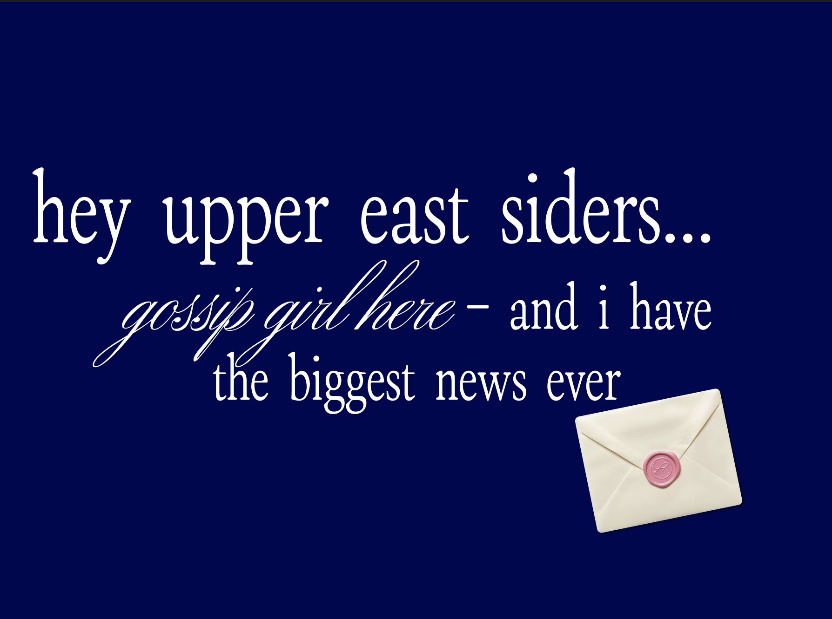

# PAGE 2 (12 points)
Landing page;
(7 points for replicating the screen + 3 points for nav bar + 2 points for doing the envelope effect)

Colors: #FFFCF6 (background), #D9DCFF (navbar buttons), #0015FF (text; xoxo opacity = 100%; gossip girl opacity: 20%)

Fonts:
nav bar + XOXO
gossip girl (same as cursive above)

Home button leads to top of this screen i.e. clicking home presents the landing page exactly
Tea button scrolls to page #3 which is right below page #2
About leads to page #4

Hovering over the envelope here makes it wiggle and clicking it does an identical function to clicking tea -> scrolls to page #3 which is right below page #2

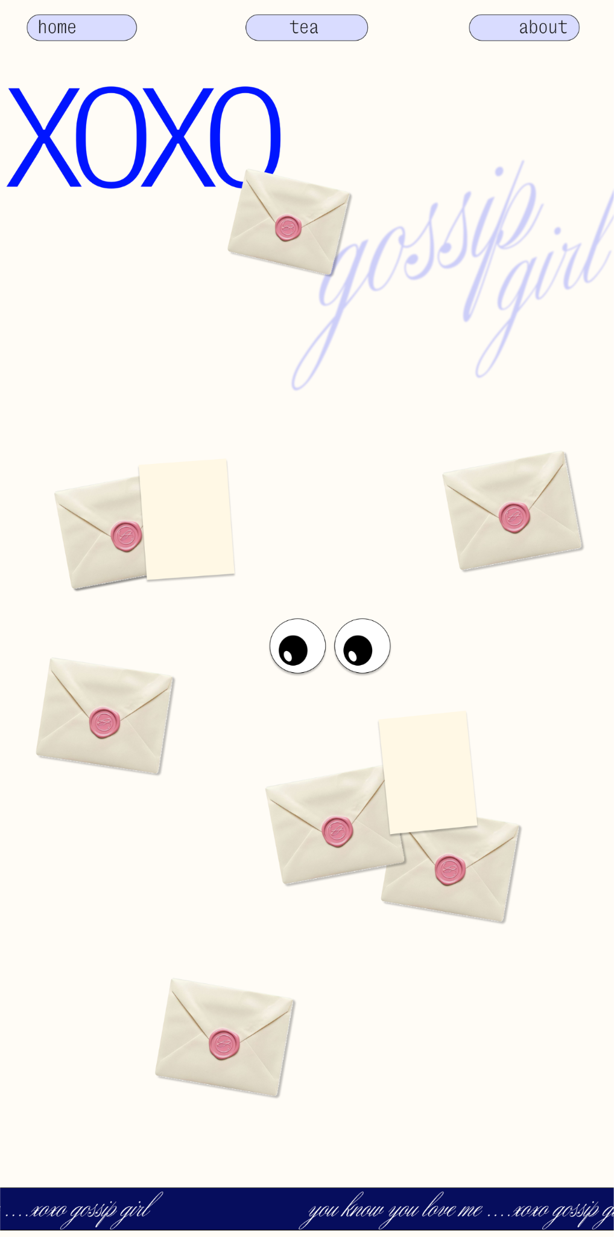

# PAGE 3 (18 points)
In continuation with page 2 (scrolling page 2 will show this);
(4 points for replicating the screen + 6 points for googly eyes (sticky + moving) + 5 points for envelopes (draggable + clickable) + 3 points for text marquee)

The googly eyes and papers can be made with simple shapes

The googly eyes stay fixed on the screen in their position (middle of screen) -> sticky element on scroll/parallax scrolling
refer: https://www.ui-layouts.com/components/sticky-scroll

Wherever the cursor goes or moves, the googly eyes look at the cursor; so if the cursor is at the right side of the screen, the googly eyes are looking right and so on..

The envelopes on clicking reveal a paper which appears next to it; this paper will have the “gossip”. ALL elements except for the eyes are draggable (can be moved around).
refer: https://jqueryui.com/draggable/

On scrolling, more envelopes show up but the googly eyes stay fixed until the end of the page

At the bottom of the page (leave a margin of 0.5in) -> add a text marquee (i.e. text scrolls right to left continuously) with text “you know you love me, xoxo gossip girl” (background same color as XOXO on #page 2) -> font same as cursive font


# PAGE 4 (10 points)
About page;
(2 points for replicating the screen + 2 points for nav bar + 6 points for phone + typing)

Needs to be exact nav bar with same positioning as Page 2
The text on this screen should look like it’s typing i.e. add typing effect for the text visible on the phone screen.
Also add a blue grainy screen as the phone screen.

Images:
Phone

Font:
Texting

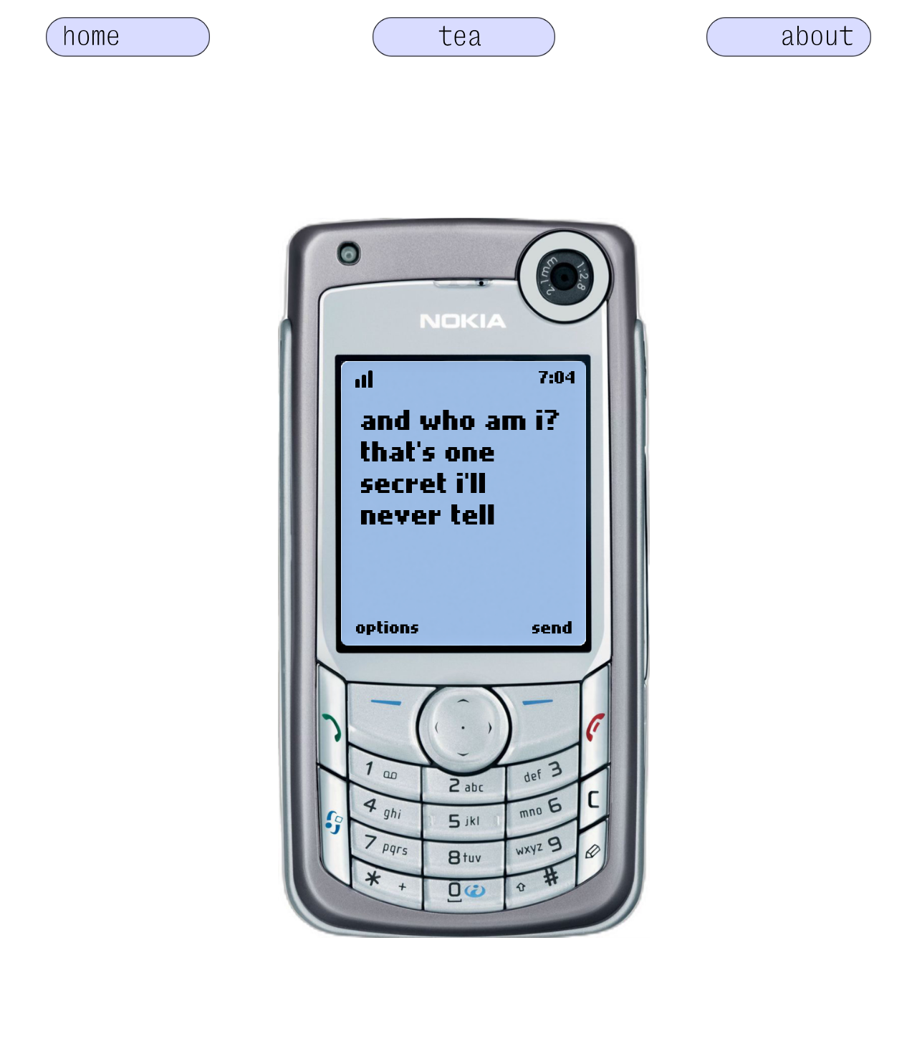

BONUS (AT MOST 8 points): if you have time and have replicated everything above, do something creative using the phone (some animation or manipulation) (for example, make the buttons look like they’re being pressed on typing, make the buttons actually type, make the send button workable and add an animation of text sending, etc.)

THIS WILL ONLY COUNT AS ADDITIONAL POINTS BUT MAIN MARKS WILL BE FOR REPLICATION SO TAKE THAT AS THE PRIORITY

(will be marked according to what you do; can get +8 points if advanced animation/good design)

